GEOL 551: Applied Petroleum Geology   
Assignment #4 - Due 3/4/2019

Nadima Dwihusna

**Homework Task:**

* 1 Structure Map DSS
* 4 Isopachs
  + Isopach DSS
  + Isopach Graneros (X bentonite) to Dss
  + Isopach Huntsman to Graneros
  + Isopach Graneros to Mowry
* 2 Cross section NS and EW
* Add 10 more depth intervals core description

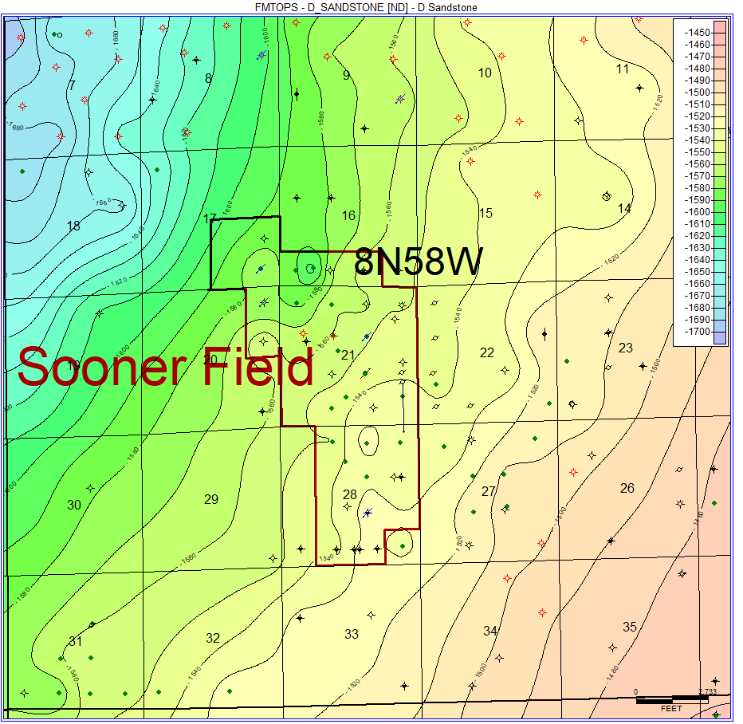

Figure 1: Structure Map of D-Sandstone from Well Log DSS Tops

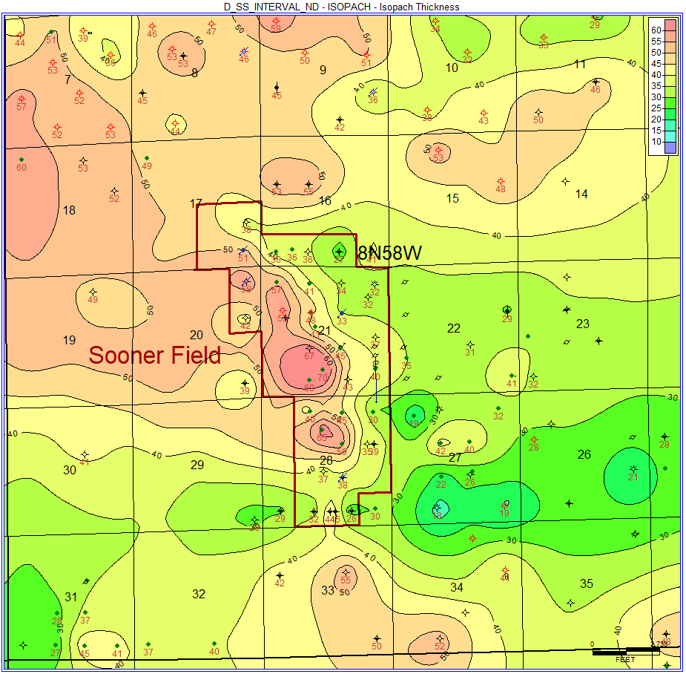

Figure 2: Isopach Map of D-Sandstone to Huntsman Shale

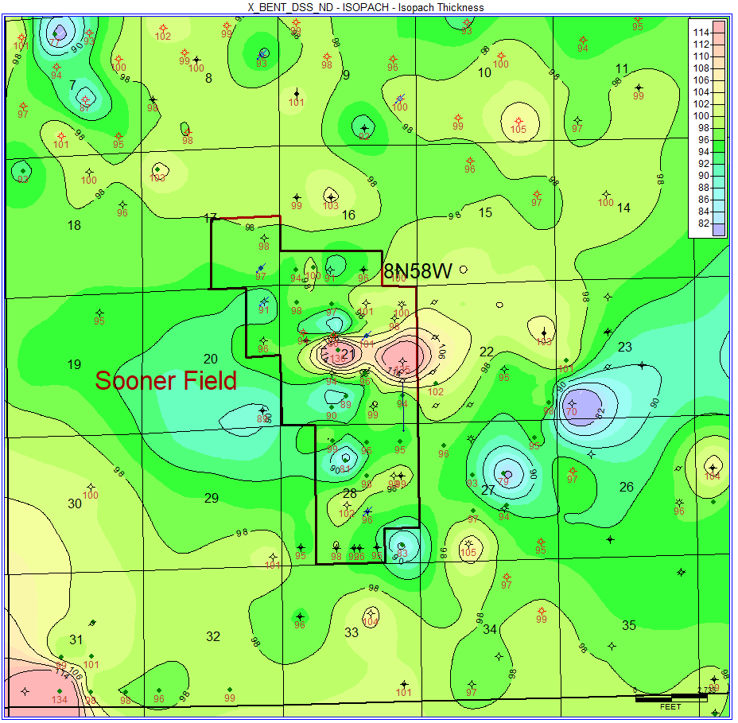

Figure 3: Isopach Map of Graneros (X-Bentonite) to D-Sandstone

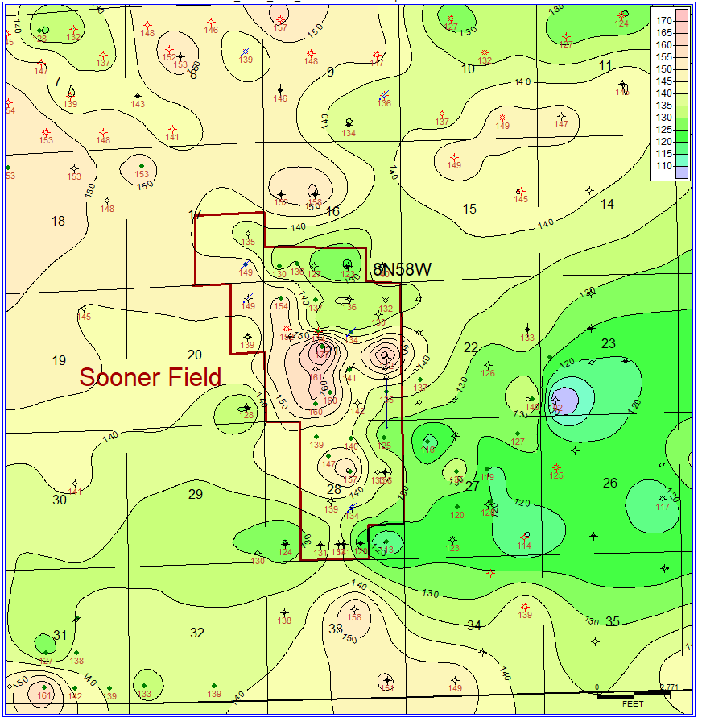

Figure 4: Isopach Map of Graneros (X-Bentonite) to Huntsman

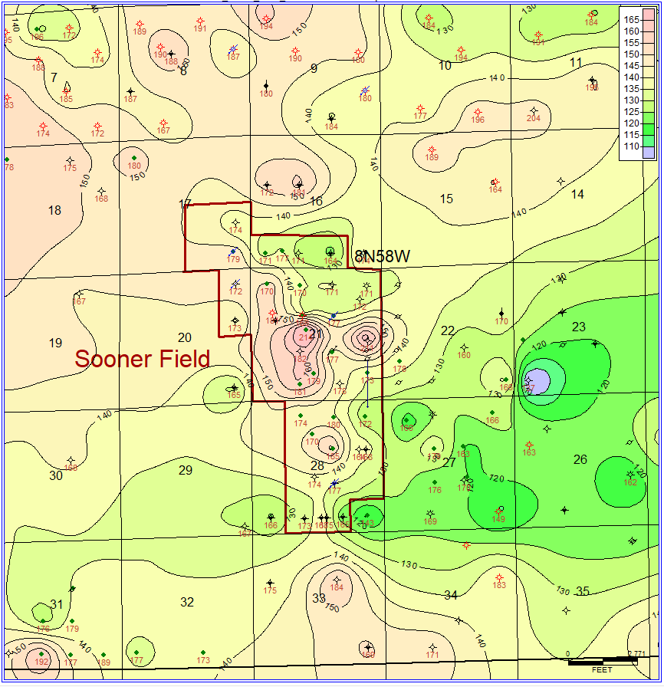

Figure 5: Isopach Map of Graneros (X-Bentonite) to Mowry

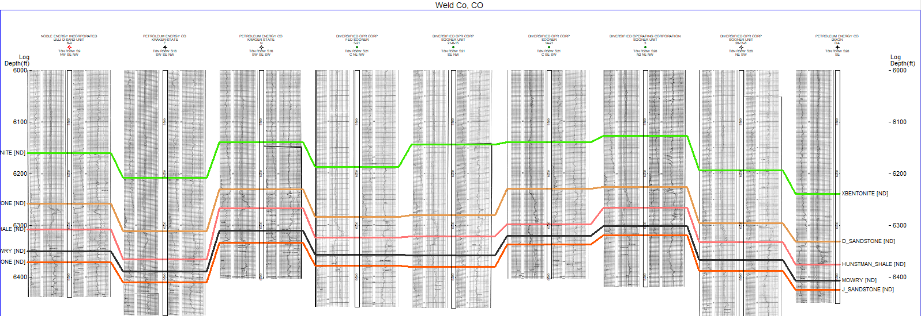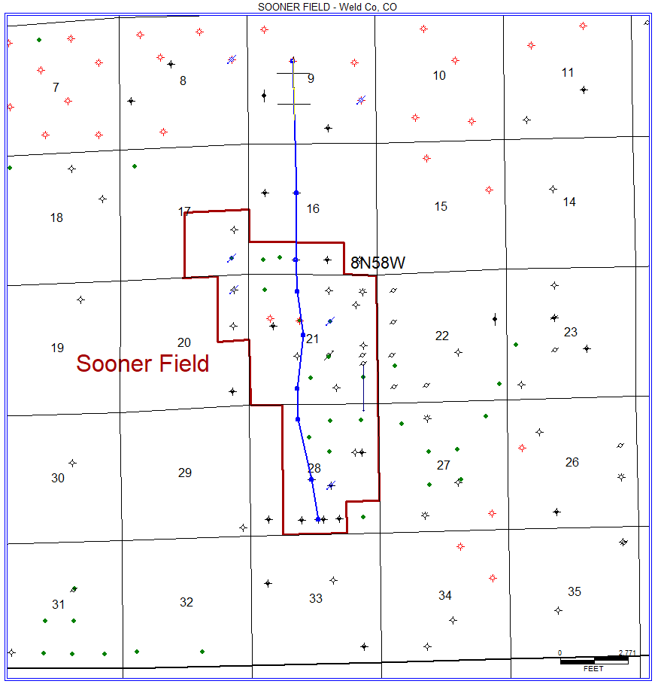

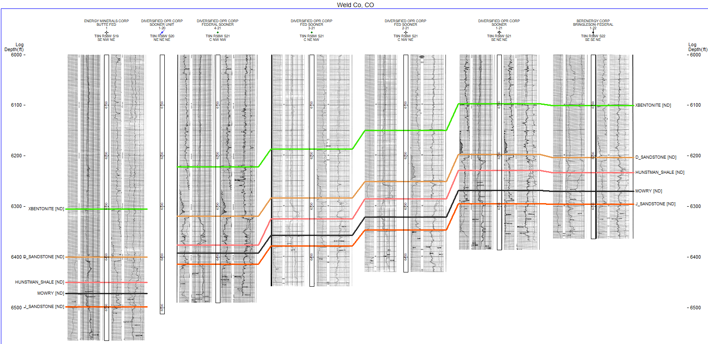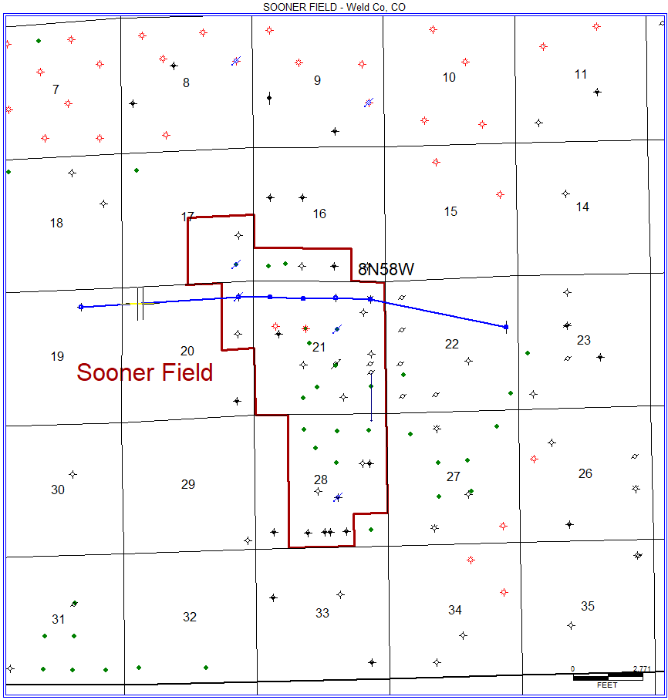



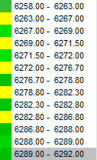

Figure 7: Added Depth Intervals for Core Data

(Depth Intervals on the right)